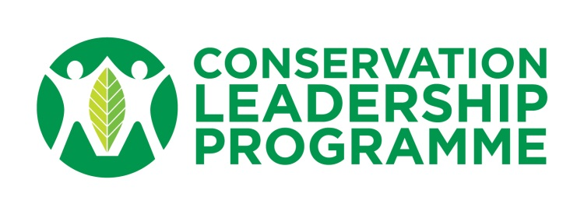

CLP Standard Logical Framework Format

If resubmitting from the previous year(s) the Final Report from your previous CLP project and a logical framework should be submitted to CLP by 24 October 2016. If the Logical Framework and Final Report are satisfactory, the team will be invited to submit a full proposal, with notification by 4th November 2016.

As part of the proposal to CLP a Logical Framework must be included. This should set out:
- the overall goal;
- project purpose;
- objectives (results);
- activities;
- indicators of success;
- means of verification; and
- important assumptions.

The logical framework should include recommendations from the expert review by CLP and be completed before filling out the application form. For advice on this, contact a CLP staff member or reference Section 3 of the Conservation Project Manual on our website.

Please provide the information below before filling-in the logical framework

- Award type you are applying for:

- If the logical framework has been submitted previously, which year:

- Explain how comments from expert reviewer on the previously submitted logical framework have been incorporated into the new one:

Information on your previous CLP Award:

- Project Title:

- Project ID:

- Host Country:

- Site Location:

- Project Duration:

- Overall Aim:

LOGICAL FRAMEWORK

Project Title:
 | Country: | Region (e.g. Africa, Asia etc.): | Project start & end date: | Date logframe is prepared:
Problems/Threats | Objectives | Objectively Verifiable Indicators | Means/Sources of Verification | Important Assumptions
 | Overall Goal
 | Project Purpose
 | Results (project objectives)
 | 0.
 | 1.
 | 2.
 | 3.
 | 4.
 | 5.
 | 6.
 | 7.
 | 8.
 | Activities
 | 0.1
 | 0.2
 | 0.3
 | 0.4
 | 0.5
 | 0.6
 | 1.1
 | 1.2
 | 1.3
 | 1.4
 | 2.1
 | 2.2
 | 2.3
 | 3.1
 | 3.2
 | 3.3
 | 3.4
 | etc
 |  |  |  | Pre-conditions

Notes:
- Enter information only into the white cells of the framework.
- Insert as many new rows (or delete any unnecessary rows) in the Results Section and Activities Section as you need for your project.

