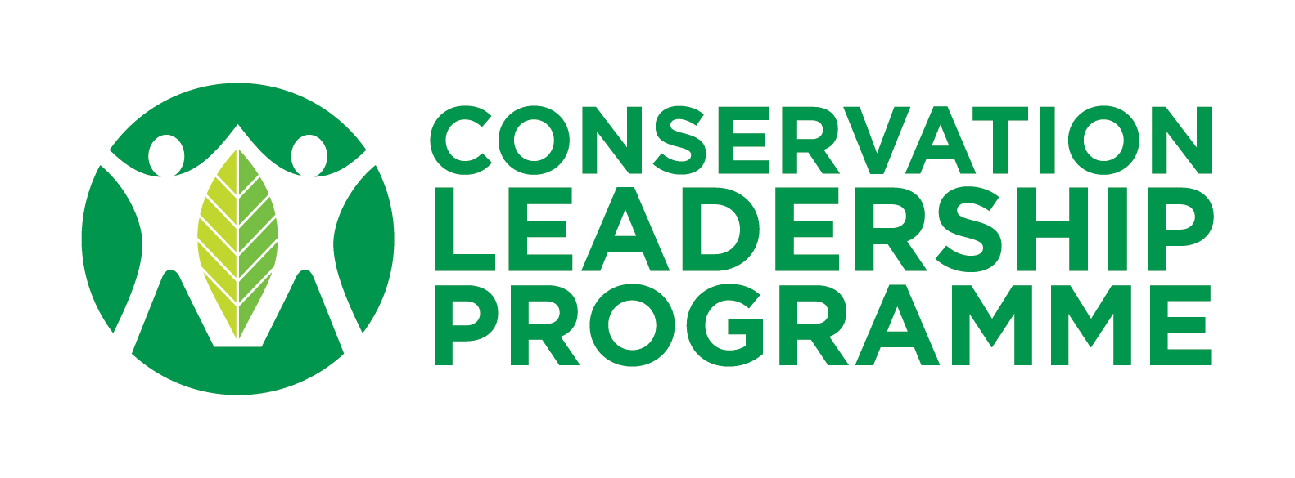

Kate Stokes Memorial Award: 2021 Application Form

The Kate Stokes Memorial Award was established in memory of Kate Stokes, former Programme Officer with the Conservation Leadership Programme (CLP), who tragically died in 2006. In her memory, a grant worth US$5,000 is awarded on an annual basis by the trustees of the Kate Stokes Memorial Trust to an exceptional team that demonstrates Kate’s same passion and commitment to biodiversity conservation.

The trustees believe that conservation will only be successful if people work together, are knowledgeable about the issues, and have the skills and abilities to effect change. As such, the Trust is committed to supporting CLP alumni who have continued their efforts to conserve threatened species and who are doing so by engaging local communities, increasing knowledge and understanding of conservation, and developing the capacity of local stakeholders.

The trustees welcome applications for funding for projects with a one year term that are focused on outreach, education and training in support of biodiversity conservation. The deadline for applications is 23:59 (UK time) on Sunday 9th May 2021. Applications will be judged by the trustees. Preference will be given to teams working in low capacity areas where it is hard to access funds for biodiversity conservation work, aiming to address specific problems at a local community level and raising local conservation awareness.

Examples of projects supported through the Award include: a youth engagement programme and outreach activities in Sri Lanka; development of a training programme and field guide for park rangers in India; and, development of a handbook for early career conservationists to understand job opportunities in the conservation sector in China. For more information on these projects and others supported by the Trust, visit the CLP website.

Kate Stokes Memorial Award Criteria
- Applications should be submitted by the proposed team leader, who must be a member of the CLP alumni network, i.e., a previous leader or member of a CLP Award, a CLP intern, or a RFP grantee or scholar.
- Applications must clearly demonstrate that the proposed project:
  - focuses on outreach to, and education for, local communities, especially young people;
  - will build local capacity for biodiversity conservation;
  - addresses a conservation priority and will deliver a concrete outcome with lasting conservation impact;
  - complements current or previously supported CLP work;
  - is feasible and cost-effective;
  - involves a team of three or more individuals with a range of experience, at least one of whom must be an early career conservationist (typically, aged under 30);
  - is no more than one year in length with a budget of no more than US$5,000.
- Applicants must clearly demonstrate that the team:
  - has the skills and experience to deliver the project; and
  - includes a proven ambassador for the work the team will be doing.
Application Instructions:
- Applications must be received by the deadline of Sunday 9th May.
- All questions in the application form must be answered completely or the proposal will not be considered.
- Applicants must meet each of the criteria outlined above.
- Email the completed form to Stuart.Paterson@fauna-flora.org with the subject: ‘2021 KSM Award’.
- If you have any questions, contact Stuart Paterson: Stuart.Paterson@fauna-flora.org.

  - General INFORMATION
Project Title:
Project Start Date: (day-month-year) | Project End Date: (day-month-year)
Project Leader:
E-mail Address:
Previous CLP Awards you have received, including Title, Year, and Type of Award (Future Conservationist, Follow-up, Leadership, Research Fellowship, Internship) and details of any CLP internship of RFP grant or scholarship:

Project Team: Provide the name, title, age, responsibility and relevant experience of each team member who will be involved in delivering the project. For senior team members, focus on experience that illustrates their credential as ambassadors for the work of the project. For junior team members, explain how the project will help their development.

  - PROJECT DETAILS
Background and Justification: What is the problem you are trying to address? Outline the need and urgency for this work. Why is this a conservation priority? What will happen if this project is not funded? (200 words)

Overall Goal: Describe the high-level goal to which this project will contribute. Explain how this project complements current or previous CLP work. (50 words)

Project Purpose: What is the purpose of this project? Explain the immediate outcome or change you hope to see as a result of this project. (25 words)

Project Objectives: Focus on two to three specific objectives for the project. The objectives are the results you want to achieve by the end of the project. If you achieve all your objectives, you will achieve the project purpose.
1.
2.
[3.]
Project Methods: What methods will be used to implement the project and help you meet the objectives? Describe the methods for each objective listed above. (300 words)
Objective 1:
-
-
-
Objective 2:
-
-
-
[Objective 3:
-
-
-]

Stakeholder readiness: How have you ensured that your target stakeholders e.g. local communities, producers, young people etc. will be ready and available to take part in project activities? (150 words)

Project Activities: In the table below, detail the specific activities that will take place to achieve each objective listed above, including the number of days and the month in which each activity will take place. (For example, activities under Objective 1 should be labelled as: 1.1, 1.2, 1.3, etc. – see example below.)

Project Outcomes: What are the expected outcomes and products of the project? What are the indicators of success? (200 words)

Other Clarifications: Please include any additional clarifications.

- PROJECT ACTIVITIES  Edit the months to reflect the 12 months from your project start date. | Jun | July | Aug | Sep | Oct | Nov | Dec | Jan | Feb | Mar | Apr | May
E.g., 1.1 Develop survey questions (15 days) | x
E.g., 1.2 Meet with community members to conduct surveys (5 days) |  | x
E.g., 1.3 Analyze survey data and make recommendations based on results (10 days) |  |  | x
Please add additional rows and/or columns as needed

  - BUDGET
Itemized expenses – For each expense, you MUST detail the unit cost and number of units/days/people. | Amount  (local currency) | Amount (US$)
Please add additional rows as needed
TOTAL:

